Thusford Gala Day
5th July
Departing Fakenham Medical Practice 9.15am
The Route

Leave the Medical Practice
Straight over the roundabout
Morrisons petrol station is on you left (E5 at pumps 3&4)
Left at the roundabout (signed All major routes)
Right at the next roundabout (A148 to Cromer and Holt)
Look out for the speed camera sign on the left
Get down to 59mph
Look out for the actual speed camera about 500 yards later
Sign for LT SNORING and a brown sign for Crossways on the left
Carry straight on
Sign for Gt. Snoring and Lt. Snoring on the right. Ignore it.
Enter the 40mph zone where LITTLE SNORING starts again
Sign for Lt. Snoring Airfield on the left. Ignore it.
Crossways is on your left. Start braking.
Bollards in the middle of the road.
Turn left into Kettlestone Road.
Down to the three way junction and turn right onto Thursford Rd.
Carry on straight past the huge potato store on your right.
(We might pause on the hard standing to gather waifs and strays)
Keep following the road – it’s quite scenic.
Around the end of the trees, there’s a big dip in the road. Beware.
Mainly straight but a few bends. Steering required.
Enter Thursford Green at the 30 signs.
To the T junction.
Turn right onto the imaginatively named The Street.

Look out for the phone box but before that turn left into the Thursford catering entrance.
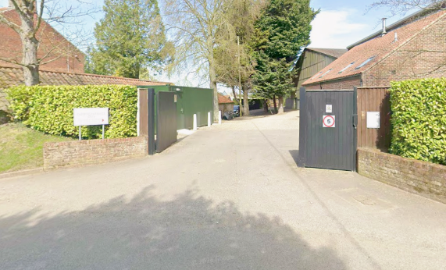
Marshals will give you your wristbands and direct you from here.

